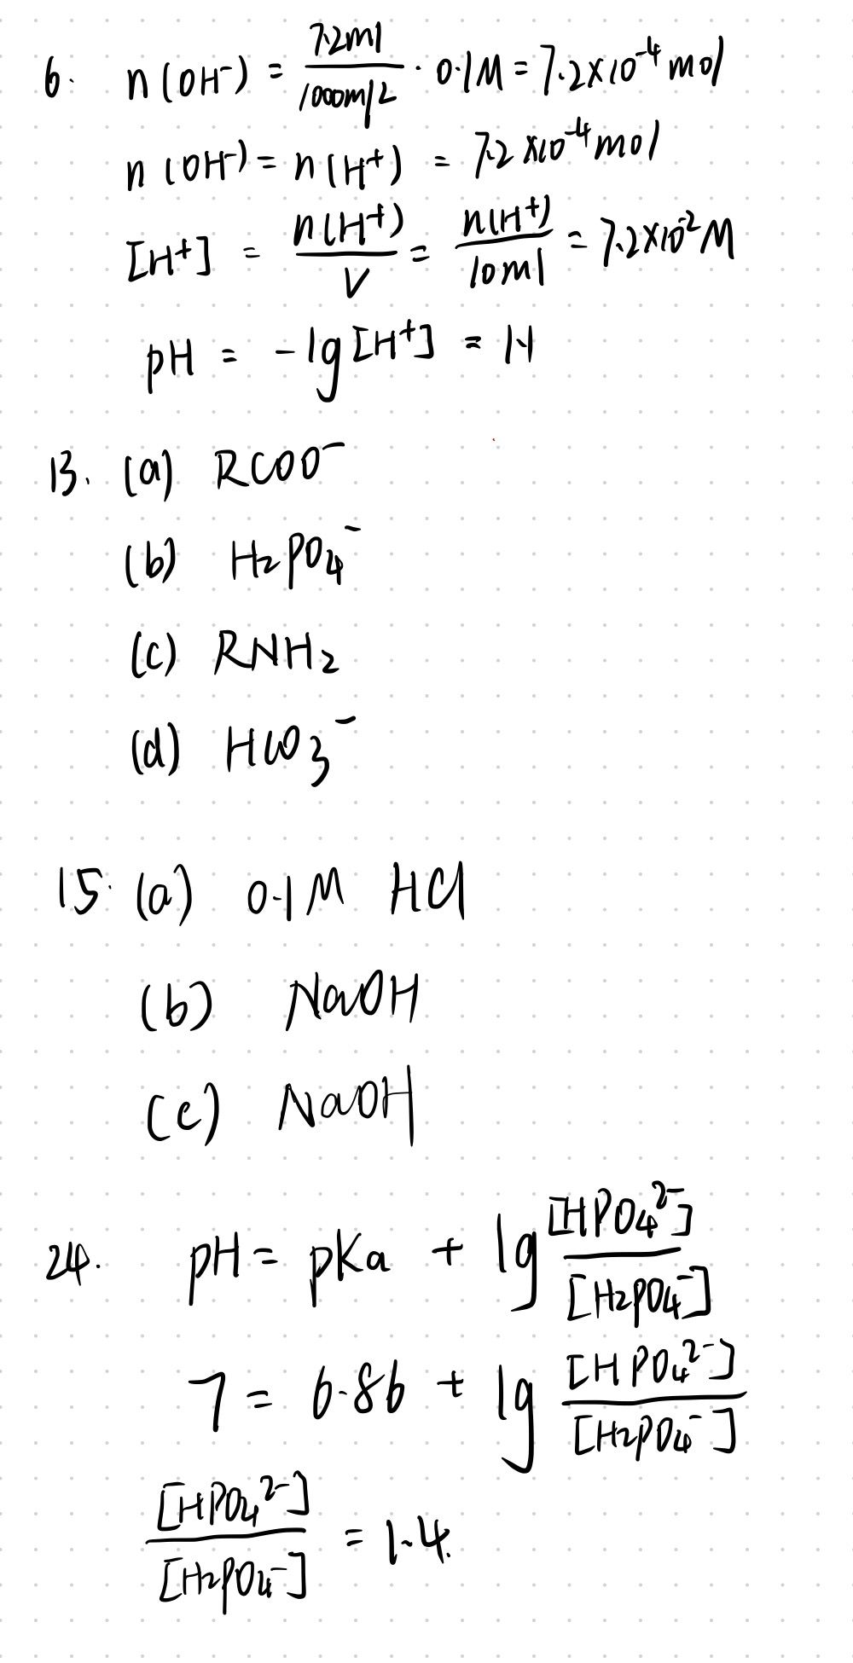

28.Acetic acid should be chosen. Because buffering capacity of acid/base system is maximal at pH=pKa, and acid/base whose pKa is closer to pH has better buffering capacity.

35.

(1) Higher pCO2 creates a new equilibrium which increase CO2(d) in blood. Thus, the concentration of H2CO3 will also increase. More H2CO3 dissociation to release more H+ and HCO3-. The result is that pH of blood will become lower than before.

(2) Hyperventilate makes pCO2 in lung decrease. Corresponding to this, the equilibrium will tend to produce more CO2 from combination of H+ and HCO3-. Hence, the concentration of H+ will be lower and pH will increase.

(3) From K2 of lactate we can know that lactate is a stronger acid than carbonic acid. Hyperventilate can make pH of blood higher so that can prevent the decreasing of pH caused by H+ released by lactic acid.